Carisbrooke Leper Hospital.
CARISBROOKE LEPER HOSPITAL
A community archaeology project will be undertaken this month to try and ascertain the location and layout of the long gone medieval leper hospital administered by St Mary's Priory, in what are now the grounds of Carisbrooke High School

Leprosy was a common scourge of the Middle Ages and, by the end of the 12th century, the hospitals were an established practice in England. The medieval leper hospital was really a hospice, as few of its inmates survived. The contagious and disfiguring nature of the disease rendered its sufferers outcasts, so the hospitals provided both isolation from the general public and prayer for the souls of sufferers. They have traditionally been represented as hopelessly grim places, although some historians now suggest life in them was no worse than in the average monastery.
The Carisbrooke hospital was established by St Mary's Priory, probably in the 14th century. The precise location is unknown. A position is marked on some early maps, at the northern extreme of the priory lands, but the maps are unlikely to guarantee anything more than an approximation. Whilst the general layout of buildings within some of the country's larger hospitals is documented, it is not at all clear what a particular provincial example would have involved. It is unknown whether the site will contain burials.
The archaeology is being organised by County Archaeologist, Ruth Waller. A programme has been planned involving members of local organisations. This will be a hands-on community project in that volunteers will be doing the excavations themselves. A geophysical survey has already been carried out within the general area. The results show interesting anomalies indicating the remains of a collapsed building, and this will form a guide for the first trenches. Of course, centuries of subsequent activity could mean the survey is just highlighting the remains of old farm structures. Building materials alone are unlikely to be conclusive, so identifying the hospital will probably come down to the dating and context of excavated artefacts.

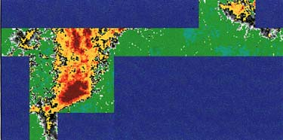 |  | The geophysical anomalies show a major spread on the left and a minor feature at top right. The latter might indicate the extremity of the hospital grounds.

