Gleaning,
To glean glenare, Latin To gather corn left in the field by the reaper.
Gleaning or ‘leasing’ was a custom allowed to the farm workers but not their legal right. A recognition of the acceptance of gleaning but emphasising the farmer’s right was the practice of leaving a ‘guard’ sheaf of corn, called sometimes ‘the policeman’ which was only to be removed by the farmer when he was ready to let the gleaners move in to the field to glean.¹
The reaper tied a bundle of corn into a sheaf using straw as a binding .
Later a ‘binder’ (a a cutting and binding machine cut the corn and the sheaves were bound with twine Stooking was the process of standing pairs of sheaves with the ears of corn interlocking. A ‘hile’or ‘harl’ was a row of stooks, usually six sheaves long on the Isle of Wight.( i.e 12 sheaths but sometimes 11, 10+ 1 to close the tunnel. This was then left for a few days to dry before carting (‘harlin’) to the threshing floor. In the 1950’s combine harvesters came into use and little corn was left to glean after the passage of the combine harvester.
For the poor agricultural labourer the gleaned corn was vital for the survival of the family and some did take care “not to welcome outsiders” and their families from the fields in which they had reaped.
Edward Weeks held the lease of Chale Manor in 1733. He was buried 22/7/1740. Grave no.386. of Chale Parish Churchyard and Robert Weeks, his son, took over the lease of the farm
Old John Green, the Parish Clerk of St Lawrence, in his ‘Memoirs’ tells of a visit in 1778 and gives an account of Robert’s benevolence.
“Feast and gleaning “
“.. there were but two gentlemen living in the parish, the Rev. Francis Worsley, the minister and Mr Weeks at Chale Farm; the only two who had the title of Mr…, the other people being called by their Christian name or Farmer…
I fear that there were not many such farmers as Mr Weeks at Chale Farm. He was a kind of benevolent gentlemen, and had a great regard for the poor. On 21st December, St Thomas's day, usually called 'Gooding day ', Mr Weeks would go into his barn and measure his wheat ( himself) and give to all the women of the parish a gallon each, for her children, herself and her husband; a good load for some who had large families. He also had a large flock of sheep, and when the time for shearing came he used to be glad to see all poor children come to pick up the locks of wool that were scattered from fleece and at supper time would call them to supper, be at the table himself, carving and asking them which they liked best, 'fat or lean'. At harvest Mr Weeks would provide the best provisions and beer as much as was sufficient, saying that their labour required such means of support.
I am sorry to hear that is has been quite different at some farms for some harvests past. It would be well and if some farmers would look in the book of Ruth, chapter 2 and see how kind farmer, Boaz, was, to his harvest men and the gleaners, and go and do likewise. I have heard that some poor men have been forced to provide for themselves on a very low price for their labour and families were in great distress, not being allowed to glean in the fields and a great deal of wheat was spoiled that might have been gleaned in good order.
I have known families get a great deal of wheat, when they were allowed to glean, which found them in bread part of the winter and enabled them to fatten a hog, pay the miller, shoemaker and other debts, by honest industry. But I am told that at present there are great quantities of wheat hoarded up in their barns and storehouses, spoiling in a shameful condition to keep up the extortionate price that has been, and now is, while their poor hard working labourers cannot get sufficient bread for their families with scanty pay. I have heard of poor men working from five o'clock in the morning till dinner time, then laying down to rest themselves, saying they would not go home to eat up what their poor children must go without; there was not sufficient for them.”

Robert Weeckes, his charity.
In 1784 he made a will leaving £166. 13s. 4. in Consuls, producing £4.13s. 4d per annum for the poor. He was buried on 12/12 /1788 in Chale churchyard, in grave no.385.
I am indebted to the author of ‘The Memoirs of William Brading’ for this information on gleaning
1 David Hoseason Morgan . ‘Harvesters and Harvesting 1840-1900. 1982
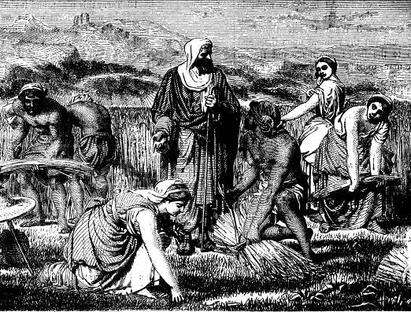

Boaz watching Ruth gleaning.

