Anglo-Saxon artefacts from Chessell.

From Hillier, George. The History and Antiquities of the .IOW 1860 checklist no. 837

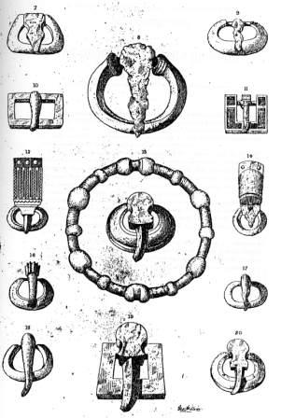
Anglo-Saxon Buckles.

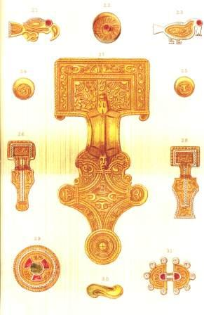

Anglo-Saxon Fibulae,
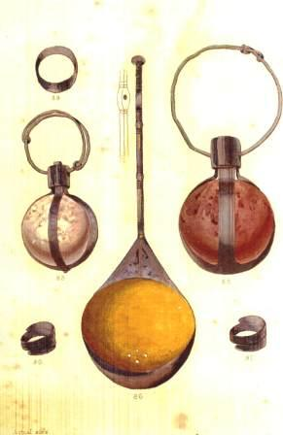

Anglo-Saxon crystals spoon and rings

