The Royal Lancastrian School.
From the website of Node Hill School

Pre-1812 - Site of current school orchards, gardens, nurseries. An iron foundry stood at the end of foundry lane.
1812 -1813 Royal Lancastrian School for boys, girls & infant founded on the site of the current year 5 & 6 block. Mr Yelf was the first schoolmaster. The site of the year 7 & 8 block was still a nursery.
1860s? - Lancastrian School becomes the Royal British Schools.
1871 - Kelly's Directory records the Royal British Schools - this consists of an infant school, boy's school & a girl's school. Mrs. Crews, head of the infants, had been there for 37 years.
1875/6 - Control of the site passes to the Newport Board of Education. The Royal British Schools becomes know as the Newport Board Schools. Mr A. Gill-Martin is appointed schoolmaster. He is there for 30 years.
1879 - Kelly's Directory records the Newport Board School. A new infants section had been built facing Upper St James' Street. This is now the school library. The school roll was about 500 boys, girls & infants.
1906 - Kelly's Directory records the Newport Board Schools, also known as the council school. In 1905 additions & improvements to the school buildings had been carried out. The school could now hold 920 children! However, the average attendance was around 720. Mr Mitchell was schoolmaster. He remained until 1924.
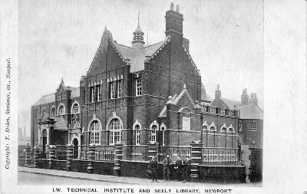
1907 � Newport County Secondary School opened in the Technical Institute / Seely library building. This building was built in 1904 on the site of a nursery and south of Foundry Lane & the Board Schools. The library, built with the support of Sir Charles Seely of Brook, became the first public lending library in the country. The Technical Institute was built to house "technical education" lectures in many subjects, including horticulture. Practical horticulture was practiced in the gardens - now the site of the big playground. Some council meetings, especially education board meetings, were held in the large hall built to the rear. This is now the music room. The Technical Institute never really functioned as planned. Instead, its rooms became the home of the Island pupil-teacher centre, which grew into the Secondary School. Miss Hinton was the first schoolmistress. To accommodate the new school, an extra wing was built. This wing now contains classrooms such as C6 (Mr Peace's room) & D2 & 3 upstairs. Two schools are now running independently on the current site of Nodehill Middle School.
1924 - Both schools continue to develop. During the First World War a number of ex-pupils die fighting in France. Two teachers of Newport County Secondary School, Mr Glover & Mr Elton, are killed in action. The Seely library also continues to function. Miss Monk was schoolmistress of the County Secondary School. In 1924 the Council School was reorganised into a girls and infants school and the boys moved to Barton. Mr Mitchell was replaced by Miss Buckler as schoolmistress.
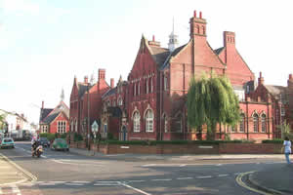
1958 - The Council School (in the year 5 & 6 block), which had become the girls' school becomes the Priory Girls School. This new school takes over the site of the Newport County Secondary School (year 7 & 8). This was because the secondary school had moved to a new purpose built site at Carisbrooke. This is now the site of Carisbrooke High School. Mrs Dudgeon is appointed Headmistress. She remains until 1970 and was the only head teacher of the Priory Girls School.
1961 - The new school is fully open. Between 1958 & 1961 the school underwent additions and improvements, including a new hall � our current school hall.
1970 - Priory Girls closes. The Island introduces a 3-tier education system & Priory Girls becomes Nodehill Middle School. The Seely library was incorporated into the fabric of the school during this period.
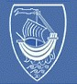
Between 1970 and the present day there have been only 3 different head teachers. Other additions are made to the school, including a new block of 1995 that linked the two parts of the school (over Foundry Lane) together.

With thanks to the Nodehill Middle School.

