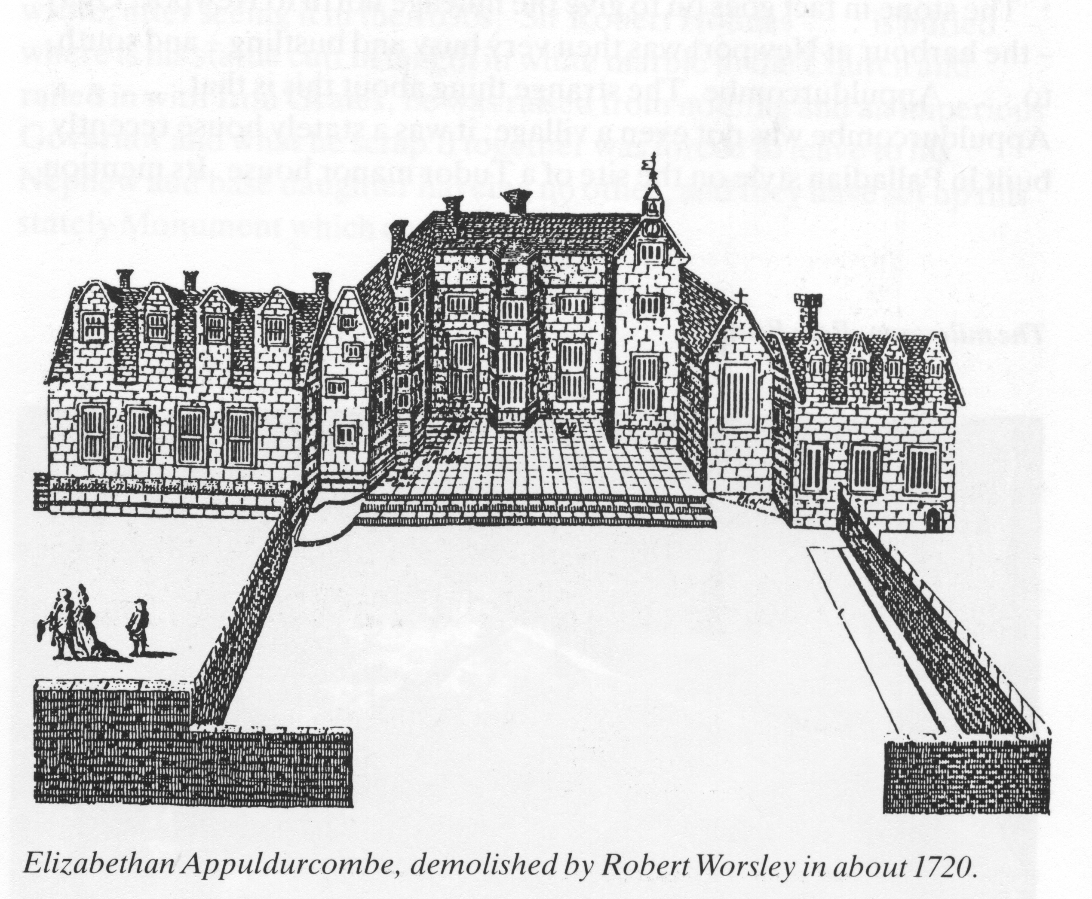

For three hundred years the Worsleys were the leading family in the Isle of Wight and an account of the family on the Island gives a background to their ownership of Chale.
Appuldurcombe is not a Domesday manor because its land was in the Manor of Wroxall that belonged to Earl Godwin before the Conquest and in 1086 it was held by the King. It was given to Baldwin de Redvers, Lord of the Island in 1090 to the Abbey of Montebourg. The Abbey established a Priory there that was suppressed in 1414. The King then granted it to the Nuns Minoresses without, (the walls of the city of London), Aldgate.
Richard Fry, who leased Appuldurcombe from the nuns of Aldgate, married Agnes, who was the daughter of the old Isle of Wight family of Hacket and when he died Agnes married Sir John Leigh, of More in Dorsetshire In about 1498 Sir John Leigh and his wife, and her son John, ( her son by her first marriage to Richard Fry) leased Appuldurcombe Manor from the nuns. Sir John Leigh had came to the Island and settled at Appuldurcombe in 1486 on his marriage. He was a favourite of King Henry VII who granted him a dispensation to hold the Manor, contrary to Act of Parliament. When he died in 1522, he left an only daughter, Anne who married James Worsley, the son of a Lancashire family. One of his ancestors, Sir Elias de Workesly (From a Manor of that name near Manchester) was a Knight in the First Crusade A.D. 1096 under Robert, Duke of Normandy and he died in Rhodes.
The Worsleys established themselves at Appuldurcombe and the family became the Lords of the Manor for the next three centuries. James Worsley (younger son of Robert Worsley of Worsley Hall,) was, in his youth, a personal page to King Henry VII, (Groom of the Robes) and later a courtier to King Henry VIII, In the Patent Roll of Henry VIII he is called, ‘ Groom of the Wardrobe of Robes.’ The King knighted him as a reward for supporting him at "The Field of the Cloth of Gold." in 1513.He obtained a new lease from the Priory of Appuldurcombe and in 1527, but after the Dissolution of the Monasteries, he acquired the estate and began by completing the manor house near the old Priory House. A drawing of this building shows a Tudor mansion with great hall, chapel, stables and an indoor tennis court, (later converted into a library.) while in front of the house was a bowling green.
Sir James died in 1538 and was succeeded by his son, Richard, who one year later entertained King Henry VIII and Thomas Cromwell at Appuldurcombe. The royal party came for hawking, and to discuss the defence of the Island which led Richard to be appointed ‘Captain of the Wight’ with responsibity was strengthening the defences. This he did thoroughly, introducing firearms to the Island and he was also given Cromwell’s office of ‘Constable of Carisbrooke Castle.’
`Richard Worsley's mother, Lady Anne Leigh, also seems to have had business with the King, for it is recorded that she persuaded him to return revenues sequestrated from the Leigh Chantry in Godshill Church. With this money she founded local schools including Godshill and she died in 1566.
In 1545 there were French landings on the Island, and Richard’s defences were successful in repelling the French
Captain Richard supported the Reformation and during the reign of Mary he resigned his post and played no part in public life until the accession of Elizabeth. Captain Richard’s brother John, purchased Chale from William Pound in 1562 but he died in 1565, leaving a widow and two young sons. Two years later tragedy occurred at the manor house when an explosion of gunpowder introduced by their father, killed the two boys. The monument in Godshill Church states: "beinge in ye lodge of Appuldurcombe the servants were dryinge of powder against ye general mowster, 1567, a sparkle flew into ye dische that sett fyre to a barrell that stood bye her, blew up a side of ye Gate House and killed ye two children, eight and nine years of adge.”
Captain Richard's brother, John, then occupied and administered the estate, and Richard’s widow married Sir Francis Walsingham, the statesman and favourite of Queen Elizabeth. A long dispute between Walsingham and John arose over the ownership of the estate but it passed to Walsingham. After several conveyances it was purchased in about 1610 by Richard Worsley, grandson of John,. from Sir Thomas Miller. Richard was knighted by King James the First in 1611 and was created a baronet later in the same year. He was appointed Captain of the Wight and was Sheriff of Hampshire in 1616 and in 1620 was M.P. for Newport. When he died in 1621, his son, Henry 1612-1666, became the second baronet. Sir Robert Worsley, Sir Henry’s son, 1643-1675 became the third baronet and it was his son, Robert 1669-1747 who became the fourth baronet in 1675.
Sir Robert Worsley, the fourth baronet, decided to pull down the Tudor mansion and the Priory buildings and "left not one stone standing." He then began to build the present mansion, a square classic structure. Sir Robert's brother the Right Honourable Henry Worsley distinguished himself in public life in many capacities. He was a barrister and a Colonel of the Guards. Later he became Governor of Barbados and Captain of the Windward Islands and then Ambassador to the Court of Portugal. He was four times M.P. for Newtown. Sir Henry died, a bachelor, in 1741, and Sir Robert had left no heirs so after his death, in 1747, the Manor passed to his cousin, Sir James Worsley of Pilewell, Hants who became the 5th baronet.
Sir James was a meticulous antiquarian and collected many details of the Island history. This work was continued by his son, Sir Thomas, the sixth baronet, and by his grandson, Sir Richard, the 7th baronet, who completed an published his "History of the Isle of Wight"₁ which is today a most valuable source of information on local history. He wrote it with many of the original charters and documents before him on his desk. Sir Richard inherited the estate in 1768 and the significance of the manor increased under his tenure. He extended the mansion and used part of it as a museum to house his collection of art treasures.₂. He married Seymour Fleming and had two children, a son Robert Edwin and a daughter, who both died before their father. He had an unhappy experience at law when his wife was accused of ‘ Criminal Conversation’ with a neighbour. He won the case but it was shallow victory when he was awarded miniscule damages. He retired from public life and retired to his Marine Villa in the Undercliff. Sir Richard’s sister Henrietta Francis married John Bridgman-Simpson, later Lord Bradford, and their daughter; Henrietta Maria, married Charles Anderson Pelham who later became Earl of Yarborough.₃ _{4.}
1. Worsley, Sir Richard.The History of the Isle of Wight. 1781.
2. Worsley, Sir Richard. Museum Worsleyanum 1798 & 1824.
3. Boucher James, E. Letters Archaeological and Historical. 1896. The Worsleys of the Isle of Wight. pp. 481-490.
4. Boynton, F.O.J. Appuldurcombe House. HMSO 1967.

