Michael Drayton.
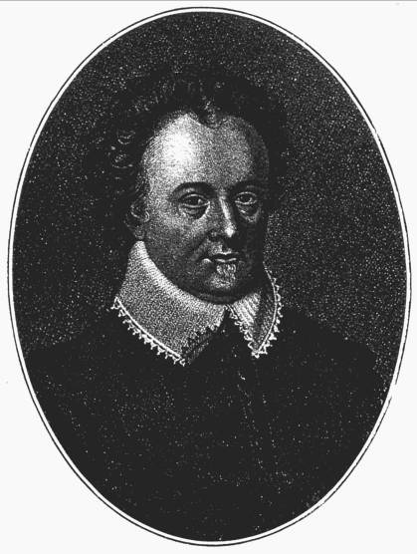

1662. Poly-Olbion: A Bulwark of England.
Michael Drayton.
Michael Drayton, 1563-1631.Poet and friend of Shakespeare
A long poetic topography of England, 1622 with a section about the Isle of Wight.
First ed. 1612.
Printed for M. Lownes, I.Brown, I Helme, and I Busbie.
Double Page Map including the Isle of Wight

The Isle of Wight.

“When the pliant muse, with faire and even flight,
Betwixt her silver wings is wafted to the Wight,
That ile, which, jutting out into the sea so farre,
Her offspring traineth up in exercise of warre,:
Those pyrats to put backe that oft purloine her trade,
Or Spainards or the French, attempting to invade.
Of all the Southern iles she holds the highest place,
And evermore have been the great’st in Britaine’s grace;
Not one of all her nymphs her sovereign favoureth thus,
Imbraced in the arms of old Oceanus;
For none of her account, so neere her bosom stand,
‘Twixt Penwith’s farthest point, and Goodwin’s queachy sand,
Both for her seat and soyle, that’s far before the other,
Most justlie may account Great Britain for her mother,
A finer fleece than her’s, not Lemster’s self can boast;
Nor Newport for her mart, o’ermatch’t by any coast.
To these the gentle south, with kisses smooth and soft,
Doth in her bosom breathe, and seems to court her oft;
Besides, her little rills, her inlands that doe feed,
Which with their lavish streams do furnish everie need;
And meades that with their fine soft grass towels stand,
To wipe away the drops and moisture from her hand;
And to the north, betwixt the foreland and the firme,
She hath that narrow sea , which we the Solent tearme,
Where those rough ireful tides, as in their straits they meet
With boystrous shocks and rores each other rudely greet,
Which fiercelie when they charge, and sadlie make retreat
Upon the bulwarkt forts of Hurst and Calshot beat,
Then to Southampton runne; which by her stores supplide
( As Portsmouth by her strength ) doth villifie their pride.”

Poly-Olbion, Song the Second.

Quoted in Hugh Noyes and put in modern form
The Isle of Wight Bedside Anthology.p.26.Drayton Cambridge Essays 1857 P.185.
` Of all the southern isles hath held the highest place,
And ever more hath been the greatest in Britain’s grace.’
See also England’s Historical Epistles For S..Smethwick and R. Cutford.[1665]
Checklist no. S. 9 Wing, D 2145.

