Quarr Abbey.

Quarr Abbey was founded in1132 by Baldwin de Riviers (Redvers, 1190-1115, the forth Lord of the Isle of Wight and Earl of Devon. and given to the monastery of Savigny in Normandy. His father, Richard de Redvers was given the Lordship of the Island by Henry I in 1102.
The exact date of the foundation is in doubt as the foundation charter is lost A copy of that Charter ( PRO…) is undated A Savigny list gives the date as August 1131 and the Chronicles of St Werburgh’s, Chester,* gives August 1132.Sir Richard Worsley in his ‘History of the Isle of Wight’ gives the foundation as year 32 of the reign of Henry I, i.e. 5th.August 1131 to 5th. August 1132,

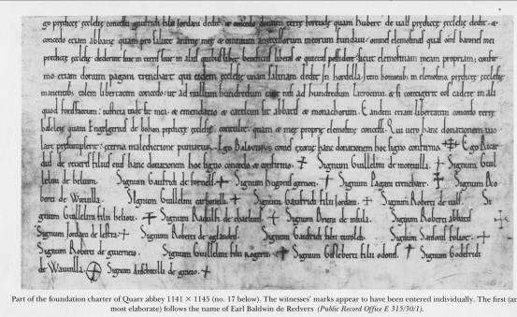

From ‘Charters of the de Redvers family, 1090-1217’ Robert Bearman.
Devon and Cornwall Record Society, Vol. 37.

The land near Binstead in the Island was the site of a limestone quarry, the fine stone from which had been used before the Norman Conquest for building part of the port of Southampton and Winchester and Chichester Cathedrals. Hence the name ‘Quarr’, a quarry The land, which in fact did not include the quarry, was given by the de Insula family, who were witnesses of the Foundation Charter.
Savigny, the mother house was at that time a Benedictine house united with Citeaux. Geoffrey of Bayeux, the Abbot sent Gervais, one of his monks, to build the monastery and he became the first abbot.
In 1147 the monastery at Savigny (with its daughter house at Quarr) became a Cistercian house.

After the reformation the monastery was surrendered to George Miles, the bailiff, of Southampton in1537 and his salvaged some of the stone.
*Werburgh (also known as Werburga) (d. February 3, 699 at Trentham) is an English saint and the patron saint of Chester.
She was born at Stone (now in Staffordshire), and was the daughter of King Wulfhere of Mercia (himself the Christian son of the pagan King Penda of Mercia) and his wife St Ermenilda, herself daughter of the King of Kent. She was a nun for most of her life, and was tutored under her great aunt Etheldreda (or Audrey), the first Abbess of Ely and former queen of Northumbria.
Werburgh was instrumental in convent reform across England. She eventually succeeded her mother Ermenilda, her grandmother Seaxburh, and great-aunt Etheldreda as fourth Abbess of Ely.
She was buried at Hanbury in Staffordshire and her remains were later transferred to Chester, of which church and monastery she became the great patroness (see Chester Cathedral). She is the last abbess whose name is recorded.
From Wikipedia

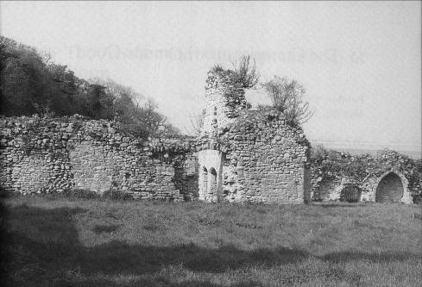

In 1901 foreign monks from the monastery of St Peter, Solesmes had to leave France They came to Appuldurcombe in Wroxall from where they bought land near Fishbourne. In 1908 they moved to the site next to the old Quarr at Binstead and founded a new Quarr Abbey and the monastery continues to this day.
‘Quarr Abbey Past and Present, was published by the Abbey in 1966.
26/07/2007
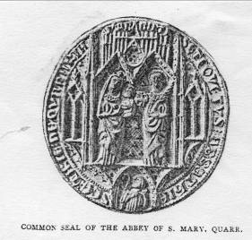
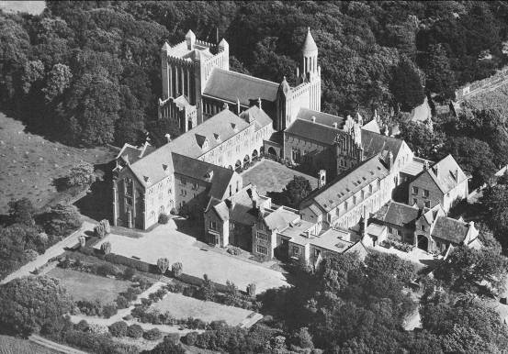

Aerial View of the modern abbey.

Bibliography.

For a comprehensive account of Quarr Abbey see:
‘Quarr Abbey and its Lands 1132-1631’, by Dom S.F. Hockey. Published by University of Leicester Press, 1970.

Other useful books include:
‘ A Short History of Quarr Abbey, by Francis Burton, privately published in 1900 ‘Quarr Abbey, Past and Present, A.D. 1132-1908’, was published by D.A. Longuet , Paris in 1910.
‘Quarr Abbey, A Short Description of the Buildings’ was published by The British Publishing Co. Ltd. in1938

