St Catherine's Oratory.

The monument known locally as 'the pepper pot' is a mediaeval oratory and pharos, a lighthouse, built near the summit (800 ft) of St Catherine Down above Chale Abbey, i.It is known that an hermitage existed on the site previous to 1312 because the Bishop of Winchester, Bishop Woodlock ₂ issued a licence* on 4th. October 1312:
".. domimm Walterum-de Langeberewe " [longbarraw ] (Langstrellgiven in Tomkins) adhermitorium supermantem de Chale in Insula Vecta nostrae dioceses in honore Santa Katerinae Virginis construendum et reparendum., quantum in nobis est, admisimus et quod in capell ibidem cowtruende divinia celebrare poterit... "
*'His permission to build the lighthouse and perform divine service'
The light was provided from a blazing brazir within but it was useless to mariners.
Two years later one stormy night in 1314 a vessel, the ' Mary of Bayonne', laden with 174 tuns (barrels) of white wine foundered in Atherfield Bay. She was part of a fleet belonging to some merchants of the King's Duchy of Aquitaine all carrying wine, loaded in Tormay, on the River Charrante in Poitou to England. The wine was consumed by the locals or sold as 'wrecks of the sea' ₃ but the owners took action to recover their loss in the King's Court-Malefactiones de Comittatu de Suthanton ₄ mentioning one Walter de Godeton. His defence that he had bought the wine in good faith from the survivors of the wreck was successful in spite of the fact that as 'Flotsam' it still belonged to the shippers. Another jury however found the Islanders to blame and they had to pay for 53 casks of wine some 227Vi marks. 5 The Church were not satisfied with this as the wine was said to belong to the Monastery of Livers in Picardy so they then took action in a Papal Court and a Bull was issued ordering Walter, in reparation and expiation, 'to make good their losses and build the present oratory and lighthouse in penance or to prevent further shipwreck'; (see Percy Stone p28. Vol. n.). A visit to the tower was recorded in the 'Gentleman's Magazine' ₆ Percy Stone thought that the anchorite's chapel and the oratory were different buildings. Both were dedicated to St Catherine but she was patron saint of hills.
Mr Percy G. Stone, the architect and local historian, repaired the tower in 1891 and he excavated the foundations of the Chapel.
Gerald Dunning excavated a barrow on Chale Down near the Oratory in 1925 ⁷ It was on the between the boundary fences of Chale and Niton parishes. He found which was thought to be a limekiln, which included a circular wall with two tunnels. The construction was deduced to be of a beacon pit from early in the 14th. Century, dated from the excavated evidence of mediaeval tile and pottery. At an Inquisition at Shide Bridge in July 1324, 29 beacons were mentioned; including the one on Chale Down watched by four men by day and two by night and were used to warn of the approach of enemy ships. In a survey of the down in 1566, part of which is reproduced, two conical stacks of wood are shown north east of the Oratory and the beacon pit and the brazier was probably fed from such stacks. It therefore seems probable that there was a beacon here between those times as well as the Napoleonic period. Photographs of the excavated pit are included ⁸and the site plan, the survey, and the diagram to show the design of the beacon are from Mr Dunning's paper.
By 1950 the tower was in need of further repair and the Owners, The Warden and Fellows of Winchester College transferred the monument to the guardianship of the Ministry of Works who completed the restoration. The National Trust now administers the monument, which can be reached from the View point car park in Blackgang Road.
1. Grid ref.SZ 4938/7729
2. Wynton (Winchester) Reg, Bishop Woodlock, AD 1305-16.
3. Whitehead J.L. The Undercliff of the Isle of Wight, p. 333 See: Wrecks of the Sea, Flotsam, Jetsom and Ligan
4. Abbrev. Placitor, Hilary 8 Edward II AD 1315.
5. Abbrev. Placitor, Hilary 20 Edward II AD 1327.
6. Gentleman's Magazine. Vol. xxvii .1757.
7. Dunning, G. Excavation of a Barrow on St Catherine Hill, Niton, Isle of Wight. Proc. Hants Field Club. 1927 Vol. 10. pp 12-24 .
8. Courtesy of Mrs Betty Williamson, whose husband, Dr James Brace Williamson, helped in the excavation and owned the photos.

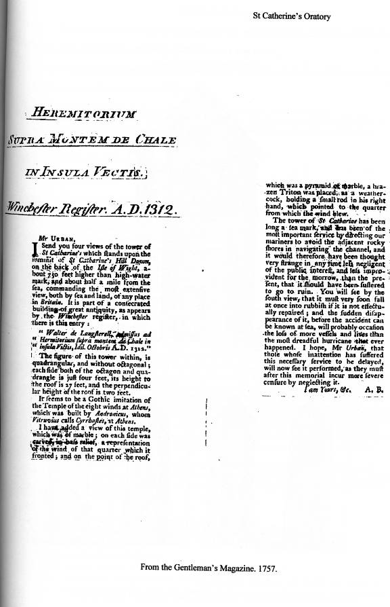

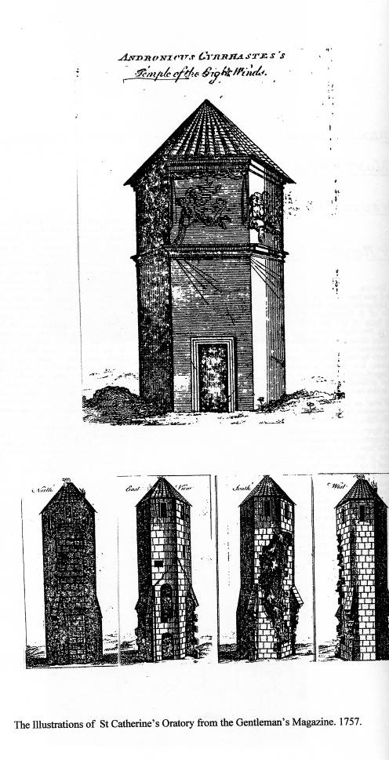
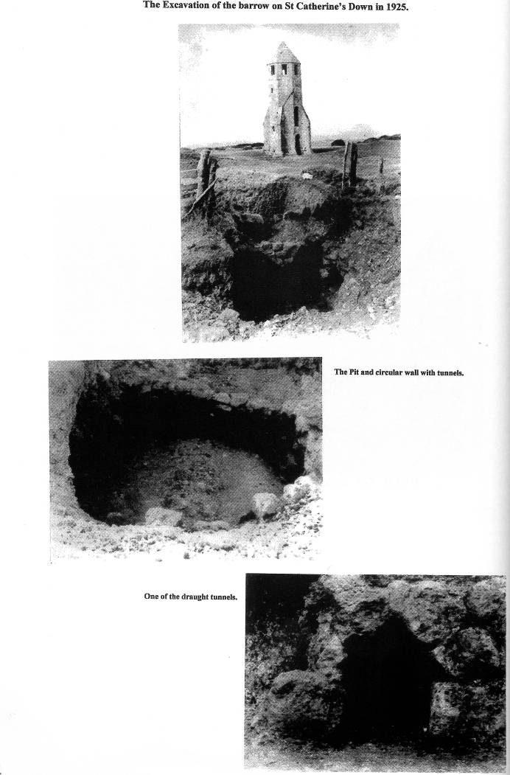

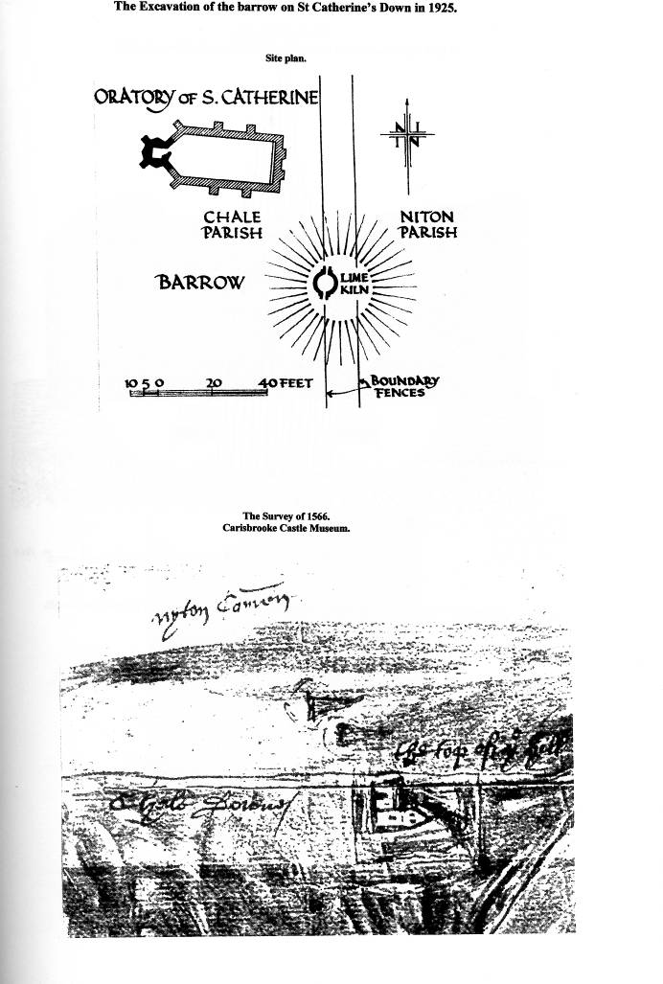

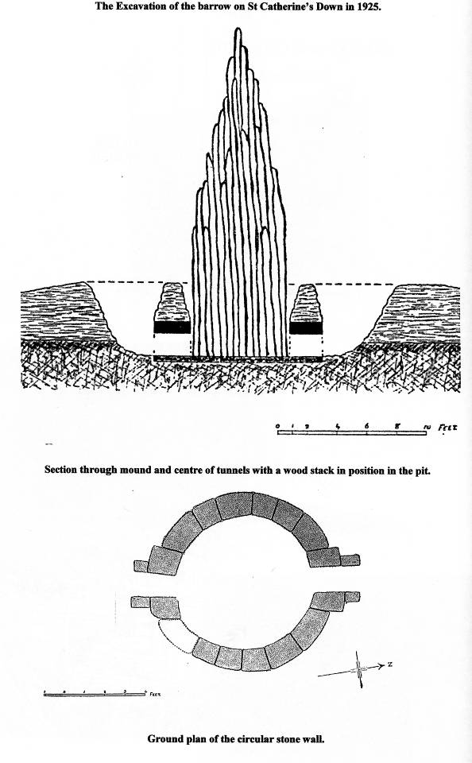

Stanley Cotton

