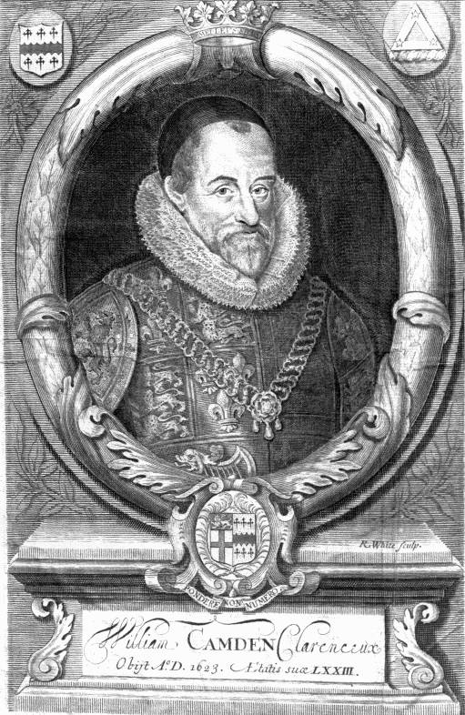

William Camden.
Frontispiece

CAMDEN, WILLIAM (1551-1623), antiquary and historian ; educated at Christ's Hospital and (1564-6) at St. Paul's School ; servitor (apparently to Thomas Cooper, schoolmaster) at Magdalen College, Oxford, 1566 ; migrated to Broadgates Hall, and afterwards to Christ Church (perhaps as servitor) ; asked grace for B.A.,1570 ; left Oxford, 1571, having been excluded from an All Souls' fellowship by the catholic fellows ; began to travel up and down England, probably subsidized by Gabriel Goodman (d. 1601), dean of Westminster, collecting archaeological material;
1578-1600, his personal tours of antiquarian investigation ; published `Britannia,' 1586; asked grace for M.A., June 1588 ; prebendary of Salisbury (though a layman), 1589-1623; published a Greek grammar, 1597; Clarenceux king-of-arms, 1597-1623; answered in his fifth edition of Britannia,' 1600, the criticisms (printed, 1599) of Ralph Brooke (or Brookesmouth) [q. v.] ; printed the epitaphs in Westminster Abbey, 1600: published certain chronicles (being some of his early collections for the 'Britannia'), ; founded a chair of history in Oxford University, 1622; memorial verses, ' Camdeni Insignia,' printed after his death by Oxford University, 1624; his correspondence printed by Thomas Smith, 1691.

D.N.B.

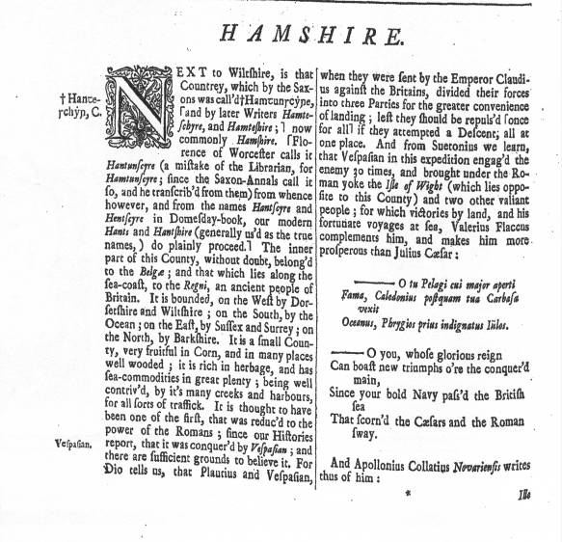

Ille quidem nuper felici Marte Britannos
Fuderat----------------------------------------

The Britains he of late o’recame
In prosp’rous war.-----------------

